# Book of Mormon Journey Site Plan

## Joshua Merrell

## WDD 130

## Overview

### Purpose

### To document an on-going, dedicated personal study of the Book of Mormon and the profound spiritual transformation it has initiated. This site aims to share how this process resulted in me becoming a more loving, humble, and hopeful person, demonstrating the practical, life-changing power of scripture.

### Audience

Members of the Church of Jesus Christ of Latter-day Saints, Christians, and all who are interested in growing their spiritual life and wanting to become a better person.

## Branding

### Website Logo



## Style Guide

### Color Palette

|  |  |  |  |
| --- | --- | --- | --- |
| **Primary** | **Secondary** | **Accent 1** | **Accent 2** |
| #F8F8FF | #B8860B | #800020 | #FFFFFF |

Please note that I do also want to incorporate navy blue (#000080) into this page as well.

### Typography

#### Heading Font: Playfair Display

#### Paragraph Font: Lato

### Navigation

Home Study of Great Worth Testimony of Love

**Content**

[put all content for the pages here, including written text and images]

**Header**

[Logo]

[Title]

Book of Mormon Journey

[Navigation Links]

Home

Study

Testimony

**Footer**

[Links (Left to Right)]

Site Plan

Top of Page

**Home Page**

[Title]

Finding a Higher Love and a Better Life in Ancient Wisdom

[Featured Image]



[Image Blurb]

My Book of Mormon Journey

[Paragraph 1]

What do you know about the Book of Mormon? Have you read it? Better yet, have you studied it? By the end of 2023, I truly didn’t know what the Book of Mormon was and I had never studied it. I was born in a Church claiming to be of God, but I never took it seriously. Scripture, the Book of Mormon being included, was read in my family growing up, but I never desired to learn from it. I coasted through Sunday School and Seminary. My faith, being upheld by my family around me, fell after I moved out. Beginning in the Spring of 2024, I found myself in a dark place spiritually and decided to do something about it. I began to study the Book of Mormon, and little by little it has transformed me. I have gained a great appreciation for the Book of Mormon, and I believe if you decide to study it for yourself, you will become all the better for it.

[Paragraph 1 Image]

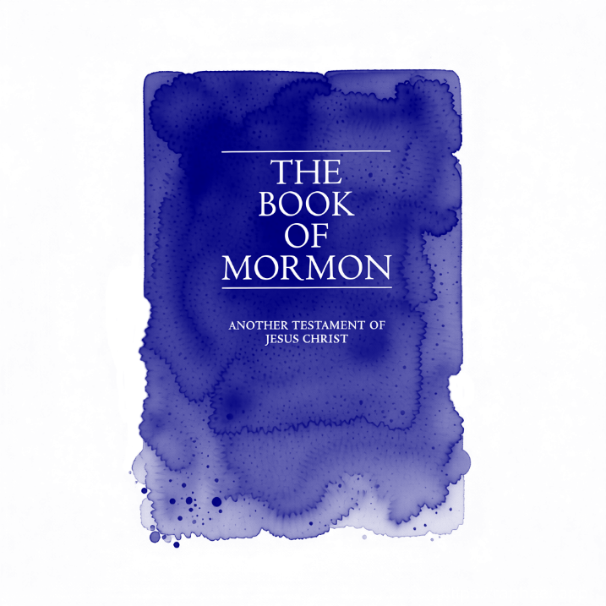

[Brief Introduction to Page Buttons]

My journey isn’t complete, but if you want to share in it, below are links to my Study and Testimony of the Book of Mormon.

[Page Buttons]

A Study of Great Worth →

A Testimony of Love →

[About Me Title]

About Me

[About Me Portrait]



[About Me Paragraph]

My name is Joshua Merrell and I am a happily married member of the Church of Jesus Christ of Latter-day Saints. I am the owner of the study and testimony shared here and sharing it with you is a big part of my journey with my Faith in Jesus Christ and His Testament: The Book of Mormon. I was baptized as a Saint in Christ’s Church in 2010, but my conversion to Jesus Christ starts now.

[Sidebar Title]

Verses of Wisdom

[Sidebar Image 1]



[Sidebar Image 2]

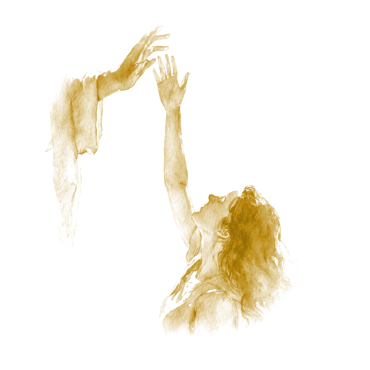

[Sidebar Image 3]



[Sidebar Quote 1]

“And now I would that ye should be humble, and be submissive and gentle; easy to be entreated; full of patience and long-suffering; being temperate in all things; being diligent in keeping the commandments of God at all times; asking for whatsoever things ye stand in need, both spiritual and temporal; always returning thanks unto God for whatsoever things ye do receive.” – Alma 7:23

[Sidebar Quote 2]

“Wherefore, brethren, seek not to counsel the Lord, but to take counsel from his hand. For behold, ye yourselves know that he counseleth in wisdom, and in justice, and in great mercy, over all his works.” – Jacob 4:10

[Sidebar Quote 3]

“And charity suffereth long, and is kind, and envieth not, and is not puffed up, seeketh not her own, is not easily provoked, thinketh no evil, and rejoiceth not in iniquity but rejoiceth in the truth, beareth all things, believeth all things, hopeth all things, endureth all things.  
Wherefore, my beloved brethren, if ye have not charity, ye are nothing, for charity never faileth. Wherefore, cleave unto charity, which is the greatest of all, for all things must fail—” – Moroni 7:45-46

**Child Page 1**

[Title]

A Study of Great Worth

[Featured Image]



[Image Blurb]

My Book of Mormon Journey

[Paragraph 1 Image]

[Paragraph 2 Image]

[Paragraph 3 Image]

[Paragraph 1]

If you didn’t already know what the Book of Mormon was, here’s the TL;DR: It is **Another Testament of Jesus Christ**. If you already know this, given here is its title page.

[Paragraph 2]

[Paragraph 3]

[Brief Introduction to Page Buttons]

[Page Buttons]

A Testimony of Love →

Home →

[Sidebar Title]

Verses of Wisdom

[Sidebar Image 1]



[Sidebar Image 2]

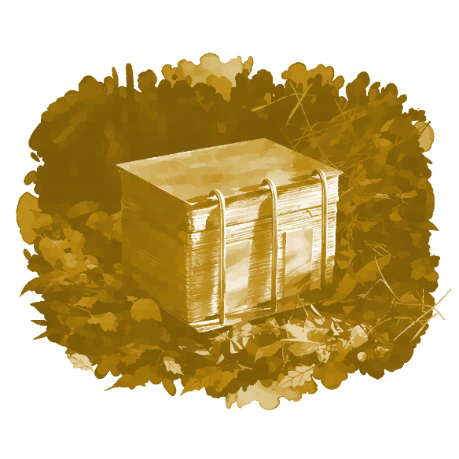

[Sidebar Image 3]

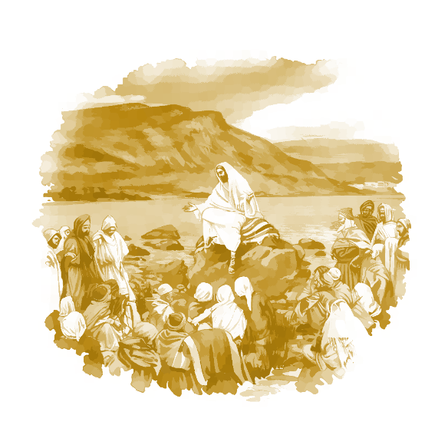

[Sidebar Quote 1]

“And now, my beloved brethren, and also Jew, and all ye ends of the earth, hearken unto these words and believe in Christ; and if ye believe not in these words believe in Christ. And if ye shall believe in Christ ye will believe in these words, for they are the words of Christ, and he hath given them unto me; and they teach all men that they should do good.” – 2 Nephi 33:10

[Sidebar Quote 2]

“And these plates of brass, which contain these engravings, which have the records of the holy scriptures upon them, which have the genealogy of our forefathers, even from the beginning—

Behold, it has been prophesied by our fathers, that they should be kept and handed down from one generation to another, and be kept and preserved by the hand of the Lord until they should go forth unto every nation, kindred, tongue, and people, that they shall know of the mysteries contained thereon.” – Alma 37:3-4

[Sidebar Quote 3]

“Wherefore, I said unto you, feast upon the words of Christ; for behold, the words of Christ will tell you all things what ye should do.” – 2 Nephi 32:3

**Child Page 2**

[Title]

A Testimony of Love

[Featured Image]



[Image Blurb]

My Book of Mormon Journey

[Paragraph 1 Image]

[Paragraph 2 Image]

[Paragraph 3 Image]

[Paragraph 1]

[Paragraph 2]

[Paragraph 3]

[Brief Introduction to Page Buttons]

[Page Buttons]

A Study of Great Worth →

Home →

[Sidebar Title]

Verses of Wisdom

[Sidebar Image 1]

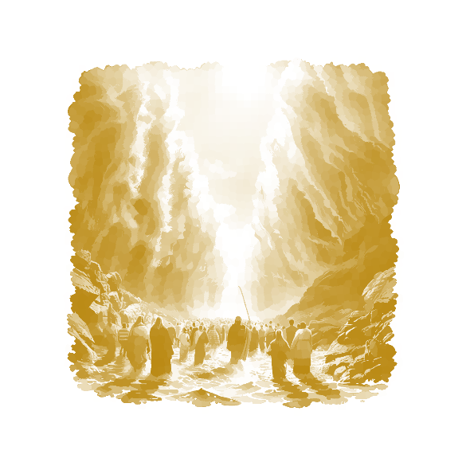

[Sidebar Image 2]

[Sidebar Image 3]

[Sidebar Quote 1]

“For behold, I am God; and I am a God of miracles; and I will show unto the world that I am the same yesterday, today, and forever; and I work not among the children of men save it be according to their faith.” – 2 Nephi 27:23

[Sidebar Quote 2]

“And if men come unto me I will show unto them their weakness. I give unto men weakness that they may be humble; and my grace is sufficient for all men that humble themselves before me; for if they humble themselves before me, and have faith in me, then will I make weak things become strong unto them.” – Ether 12:27

[Sidebar Quote 3]

“And when ye shall receive these things, I would exhort you that ye would ask God, the Eternal Father, in the name of Christ, if these things are not true; and if ye shall ask with a sincere heart, with real intent, having faith in Christ, he will manifest the truth of it unto you, by the power of the Holy Ghost.” – Moroni 10:4

**Wireframes**

### Home

### Child Page 1

### 

### Child Page 2

### 

**THIS IS AI GENERATED INFO IS TO BE USED TO HELP ME SET UP THIS STIE PLAN. DO NOT USE THIS INFO TO ACTUALLY CREATE THE SITE. THIS WILL BE REMOVED WHEN THE SITE PLAN IS FINISHED.**

**My Book of Mormon Journey Site Plan**

[Your Name Here]

WDD 130

**1. Overview**

**Purpose**

The primary purpose of *My Book of Mormon Journey* is to document a year-long, dedicated personal study of the Book of Mormon and the profound spiritual transformation it initiated. The site aims to share how this process resulted in becoming a more **loving, humble, and hopeful** person, demonstrating the practical, life-changing power of scripture.

**Audience**

The target audience includes:

* Members of The Church of Jesus Christ of Latter-day Saints looking for personal study motivation and inspiration.
* Individuals of other faiths who are curious about finding a deeper, more spiritual connection with Jesus Christ.
* Anyone seeking **hope** and practical guidance on how to become a more **loving and humble** person.

**2. Branding**

**Website Logo**

The logo will be a simple visual element (e.g., stylized initials "J M" or a symbol of light/growth) integrated into the header.

**Image Placeholder:** https://placehold.co/60x60/800020/F5F5DC?text=JM

**Style Guide**

**Color Palette**

|  |  |  |  |
| --- | --- | --- | --- |
| **Role** | **Color Name** | **Hex Code** | **Purpose** |
| **Primary** | Cream | #F5F5DC | Main background color (clean, warm, peaceful). |
| **Secondary** | Sea Green | #2E8B57 | Main structural elements, body text, strong visual support (growth, life). |
| **Accent 1** | Burgundy | #800020 | Headings, key calls-to-action, high-impact elements (sacred, authoritative). |
| **Accent 2** | Light Gray | #E0E0E0 | Subtle background for sidebars, borders, and footer (neutral contrast). |

**Typography**

* **Heading Font:** **Playfair Display** (Elegant, classic, sophisticated)
* **Paragraph Font:** **Lato** (Clean, modern, highly readable sans-serif)

**3. Navigation**

The navigation will be clear and simple, connecting the three main sections of the site.

|  |  |  |
| --- | --- | --- |
| **Home** | **A Study of Great Worth** | **A Testimony of Love** |

**4. Content**

**Home Page**

**Headline:** **Finding a Higher Love and a Better Life in Ancient Wisdom**

|  |  |  |
| --- | --- | --- |
| **Content Element** | **Text Focus** | **Image Requirement** |
| **Main Text (Introduction)** | 3-4 paragraphs (150-200 words) introducing the year-long study, the personal transformation (becoming more loving/spiritual), and inviting the reader to explore the journey and testimony. | **Logo Image** + **Image 1:** Scripture image (open Book of Mormon, ancient scroll) |
| **Call-to-Action** | Short, inviting description for the two internal pages with links. | **Image 2:** A peaceful or reflective nature/landscape image. |
| **Testimony Snippet** | A short, powerful statement of personal belief. | - |

**Child Page 1: "A Study of Great Worth"**

**Headline:** **The Transforming Power of Humility**

|  |  |  |
| --- | --- | --- |
| **Content Element** | **Text Focus** | **Image Requirement** |
| **Main Text (Process)** | 3-4 paragraphs (approx. 200 words) detailing the study **process** and focusing on the core theme of **Humility** as the gateway to greater love and spiritual knowledge. | **Image 1:** Image illustrating the act of deep study (hand on scripture, illuminated). |
| **Key Insights Section** | Bulleted list of 3-5 practical spiritual lessons derived from the Book of Mormon about how to achieve or maintain a humble heart. | **Image 2:** Subtle illustration of spiritual growth or light (sapling, path toward light). |
| **Navigation Link** | Working links back to Home and forward to A Testimony of Love. | - |

**Child Page 2: "A Testimony of Love"**

**Headline:** **My Declaration of Hope and Eternal Love**

|  |  |  |
| --- | --- | --- |
| **Content Element** | **Text Focus** | **Image Requirement** |
| **Main Text (Testimony)** | 3-4 paragraphs (approx. 200 words) serving as your full, personal testimony of the book's truth and power. Focus on the final, desired outcome: instilling **Hope**—hope in the reader, hope in those around them, and hope for the future. | **Image 1:** A picture or symbol of the Savior, Jesus Christ, as the source of love. |
| **Reflection/Future** | A concluding paragraph reflecting on the value of this recorded testimony for future spiritual strength. | **Image 2:** Image of two hands clasped, or a symbol of unity/fellowship. |
| **Navigation Link** | Working links back to Home and A Study of Great Worth. | - |

**5. Wireframes**

**Home Page Wireframe (Content Left, Sidebar Right)**

|  |  |
| --- | --- |
| **Element** | **Layout/Style Notes** |
| **Header (Full Width)** | Logo, Site Title, and Navigation. Background: Cream, Text: Sea Green/Burgundy. |
| **Main Headline (Full Width)** | **Finding a Higher Love and a Better Life in Ancient Wisdom** (Burgundy, Playfair Display). |
| **Main Content (Left - ~65% width)** | Introduction and Call-to-Action blocks. Lato font. |
| **Image/Sidebar (Right - ~35% width)** | Background: Light Gray. Contains **Image 1**, **Image 2**, and the Testimony Snippet/Quote. |
| **Footer (Full Width)** | Copyright, final links. Background: Light Gray, Text: Sea Green. |

**Child Pages Wireframe (Template)**

|  |  |
| --- | --- |
| **Element** | **Layout/Style Notes** |
| **Header (Full Width)** | Consistent with Home Page. |
| **Main Headline (Full Width)** | Page Title (Burgundy, Playfair Display). |
| **Main Content (Left - ~65% width)** | Main narrative text and bulleted lists/reflection section. Lato font. |
| **Image/Sidebar (Right - ~35% width)** | Background: Light Gray. Contains **Image 1**, **Image 2**, and a supporting scripture/quote. |
| **Footer (Full Width)** | Consistent with Home Page. |